Requires Finance Project Lobby Element– CRIM 0553

|  |  |  |  |  |
| --- | --- | --- | --- | --- |
| **Ver** | **Date** | **Author** | **Comments** | **Reviewed by** |
| 1 | 15/02/2021 | Tom Bell | CRIM 0553 | TBC |
|  |  |  |  |  |

Requirements 2

Prerequisites 2

Solution Overview 2

Solution Details 2

Security 3

Companies 3

Data Migration 3

Test Steps 3

Technical Implementation 3

Requirements

A lobby element list is required that shows the Projects that have Status initialised. This lobby element must be located in the “General Accounting, 2021-03-8” lobby.

Prerequisites

<Describe any pre-requisites that this development may rely upon, data configuration or other developments>

Solution Overview

A lobby element with a list of projects that have status “Initialised”. The lobby element is called “Requires Finance Project Approval”.

# Lobby Element Logic

List Project ID and Project Name and Project Planned Start Dates for Projects that have Project Status set to “Initialised”.

# Functionality

When clicking into a line from this Lobby Element, must open the Contract Management > Sales Contract Sales Contract screen for the selected Project ID (Sales Contract).

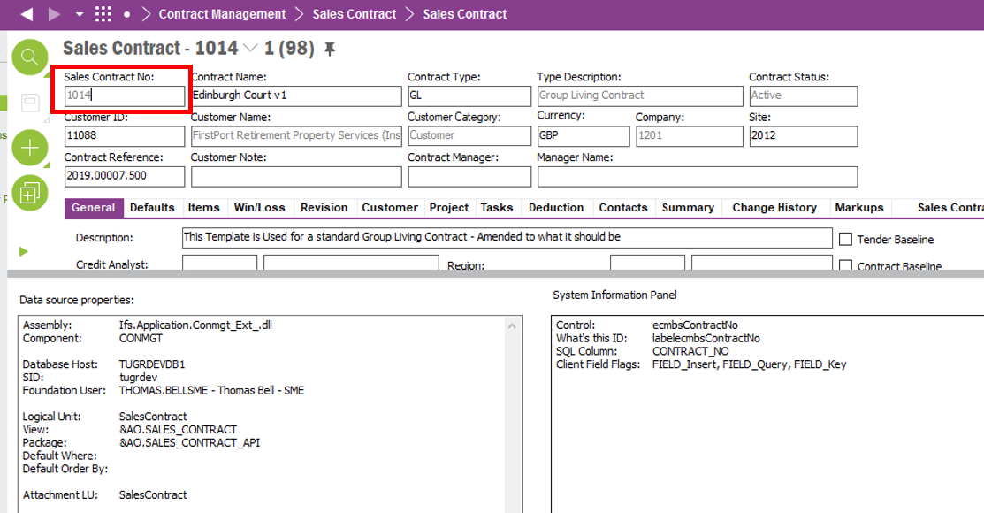

# Example

The below table shows the columns Lobby Element must detail. The lobby element must be listed with the earliest Project Planned Start Dates at the top of the list.

|  |  |  |
| --- | --- | --- |
| **Project ID** | **Project Name** | **Project Planned Start Date** |
| 239874 | Project Name 1 | 01/04/2021 |
| 329847 | Project Name 2 | 06/06/2021 |

The lobby element must appear on the **“General Accounting, 2021-03-8” lobby** as per the screenshot below.

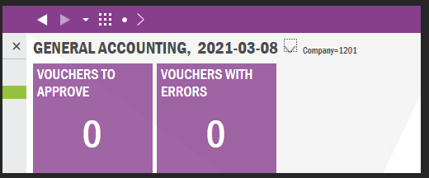

Solution Details

The below screenshot shows the Project screen. If the Status (red box) is set to ”INITIALISED” then this Project ID and Project Name and Planned Start date (in blue) would appear in the Lobby Element.

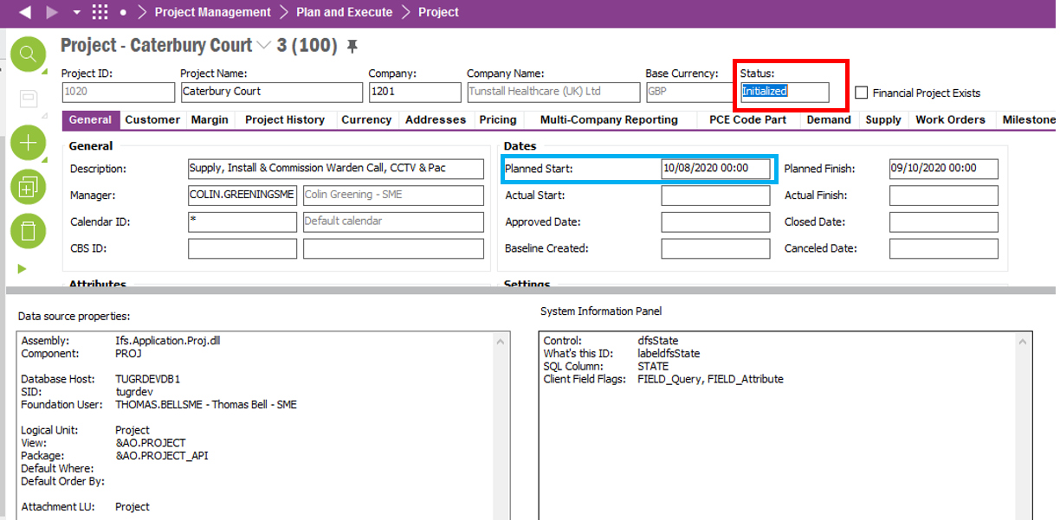

**Technical.**

Field Definitions.

<New Field/CLU Definition>

|  |  |  |  |  |  |  |
| --- | --- | --- | --- | --- | --- | --- |
| New DB Object Name | DB Object Item/Field Names | Item Description | Item Data Type | Item Syntax | Calculation Spec, if Derived | LOVs/Enums/Is Mandatory? |
|  |  |  |  |  |  |  |
|  |  |  |  |  |  |  |
|  |  |  |  |  |  |  |
|  |  |  |  |  |  |  |
|  |  |  |  |  |  |  |
|  |  |  |  |  |  |  |
|  |  |  |  |  |  |  |
|  |  |  |  |  |  |  |
|  |  |  |  |  |  |  |
|  |  |  |  |  |  |  |
|  |  |  |  |  |  |  |
|  |  |  |  |  |  |  |

Security

<Define security controls> (Who needs access to this and will it be restricted from any other users etc)

Auto Populate for All Users.

**Default Advanced Invoice Tax Code Field** - Create, Edit and Delete privileges for Financial Accounts.

Companies

Applies to the following companies. All.

|  |  |
| --- | --- |
| **Company** | **Required (Y/N)** |
| 1201 | Y |
| TBC |  |
|  |  |

Data Migration

<Describe any data migration impacts this development may have – i.e additional data to be migrated>

Test Steps

<Steps that needs to be taken to test this change. Please provide expected results> Updated post solution.

|  |  |  |
| --- | --- | --- |
| **No** | **Script\Test Steps** | **Expected Result** |
| 1 | Create Project and set status to initialised | See in lobby element project ID, Project description and Start date of project |
| 2 |  |  |
| 3 |  |  |
| 4 |  |  |
|  |  |  |
|  |  |  |

Technical Implementation

<Completed by the technical developer - Technical solution, list packages, functions, Custom menus created etc >

* Lobby Name: Tunstall Financial Accounts Lobby <Date>
* Lobby parameters: Company, Cash Flow Analysis Id, Program ID
* Data Source Name - C_EA_Initialized_Projects
* Element name:

Initialized_Projects - Title > Requires Finance Project Approval

* Permissions granted for the lobby - IFS_ALL

